A n-tier architecture is a physical structuring mechanism, while a n-layer architecture is a logical structuring mechanism.

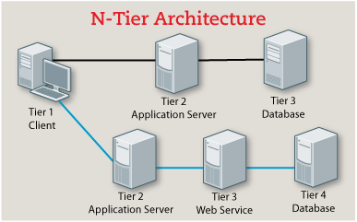

Overview of a three-tier application.

